System Specifications

* PV Array of 50 ( parallel strings ) and 10 ( series connected modules per string ).
* MPPT ( P&O Vref Algorithm used for calculating maximum power point tracking).
* Boost Converter

Specifications and Calculations ( reference book M.H.Rashid )

Vinput=250-350V

Vout=600V

Rated Power =100Kw

Fs=5KHz

Current ripple = 5% & voltage ripple = 1%

Current input = 100Kw/250 =400A

Current ripple(Ir) = 5%of400 =20A

Voltage ripple (Vr) = 1%of600 = 6V

Output current = 100Kw/600 =166A

Inductance Value = Vip(Vop-Vip)/(Fs*Ir*Vop) = 1.45mH

Capacitance Value= Iop(Vop-Vip)/(Fs*Vr*Vop)= 3227uF

Rload=2ohm.

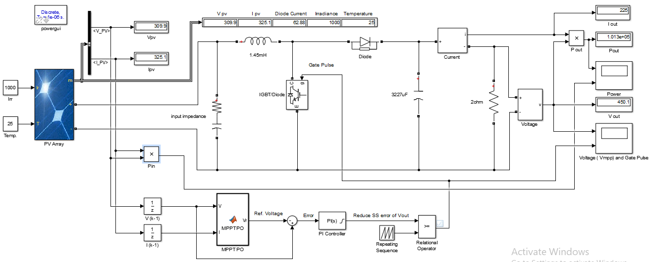

Fig : simulation circuit

**Irradiance Values with corresponding maximum power and voltage (output)**

|  |  |  |  |  |  |  |
| --- | --- | --- | --- | --- | --- | --- |
| Irradiance  ( w/m2) | Power  ( max in W ) | Power  ( output from simulation in W ) | Voltage  ( output in Volts ) | Current  ( output in Amp.) | Ipv  ( in Amp.) | Vpv  ( in Volts) |
| 1000 | 1.066e^5 | 1.01e^5 | 454 | 225.3 | 326.6 | 309.4 |
| 800 | 8.589e^4 | 8.635e^4 | 414 | 207.8 | 293.7 | 292.4 |
| 600 | 6.475e^4 | 6.25e^4 | 355 | 180.2 | 220.9 | 294.2 |
| 400 | 4.313e^4 | 4.301e^4 | 293 | 146.6 | 147.4 | 292.7 |
| 300 | 3.219e^4 | 2.69e^4 | 232 | 116.2 | 116 | 231.9 |

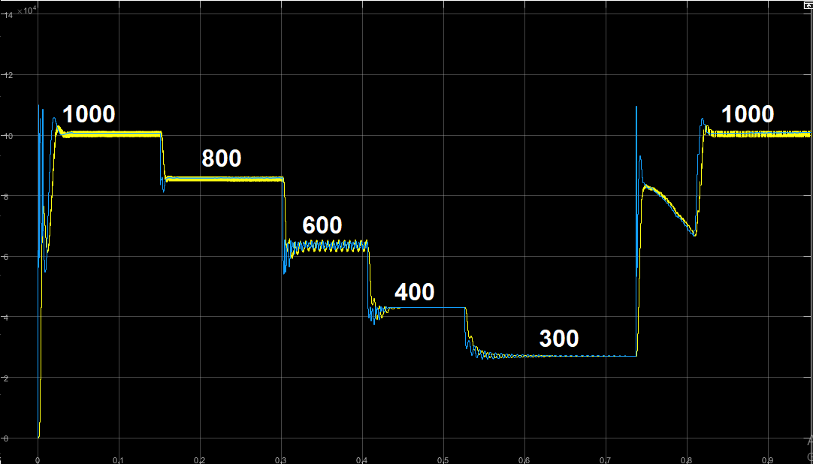

**Figure showing :**

**Power Vs Time , varying irradiance [ 1000, 800, 600, 400, 300 ] W/m^2 , at 25 deg. Temperature**

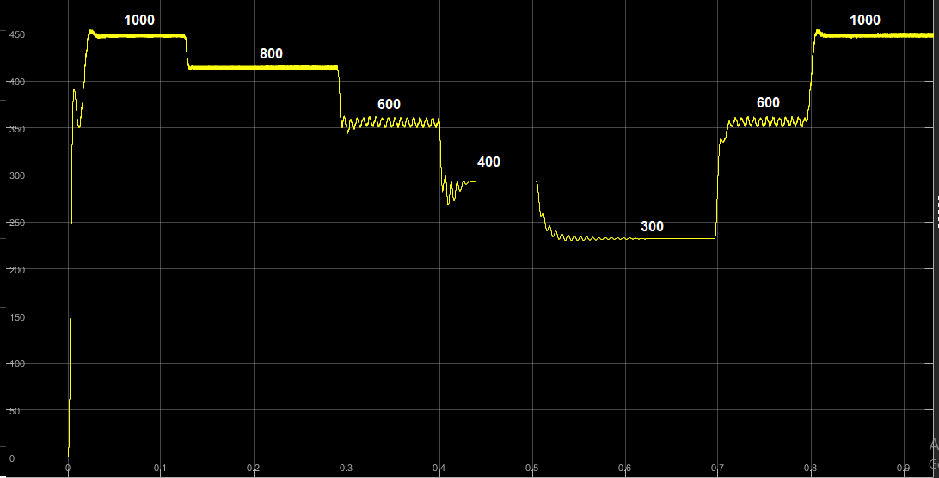

**Figure showing :**

**Voltage Vs Time , irradiance [ 1000, 800, 600, 400, 300 ] W/m^2 , at 25 deg. Temperature**

* At Irradiance 1000 W/m2 – Pout ( in scope ) = 1.01e^5 kW

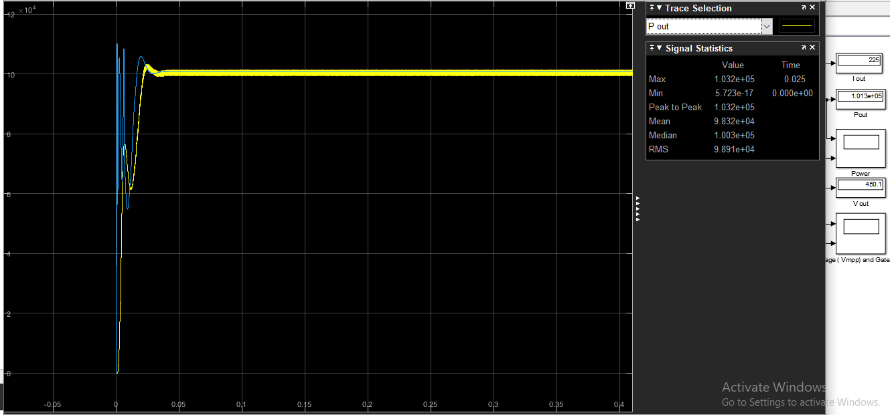

* At Irradiance 800 W/m2 – Pout ( in scope ) = 8.63e^4

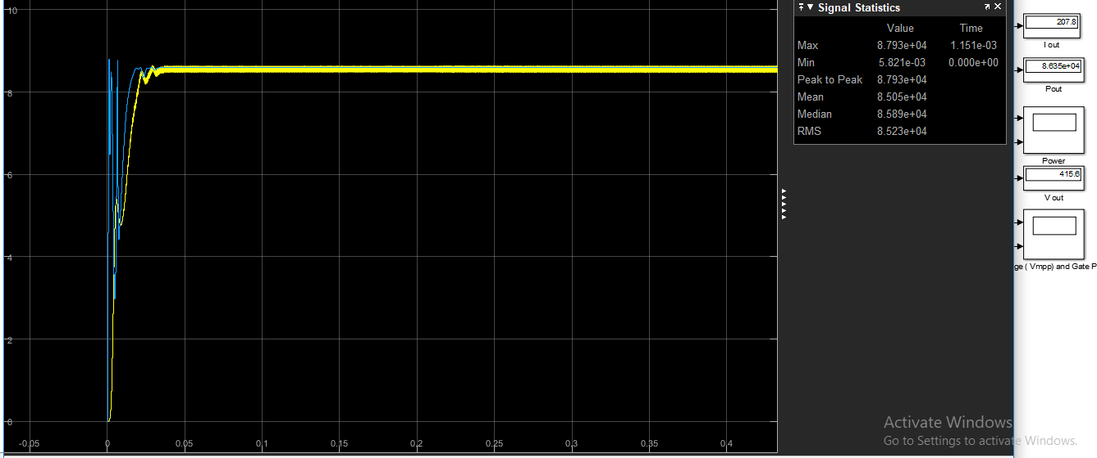

* At Irradiance 600 W/m2 – Pout ( in scope ) = 6.25e^4

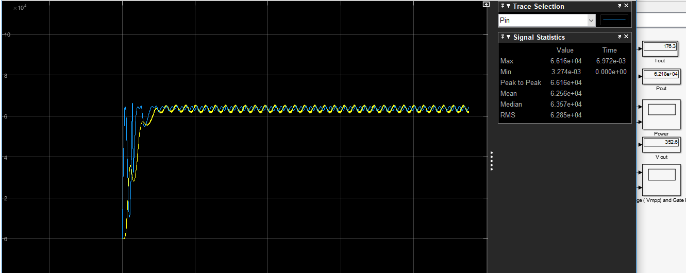

* At Irradiance 400 W/m2 – Pout ( in scope ) = 4.301e^4

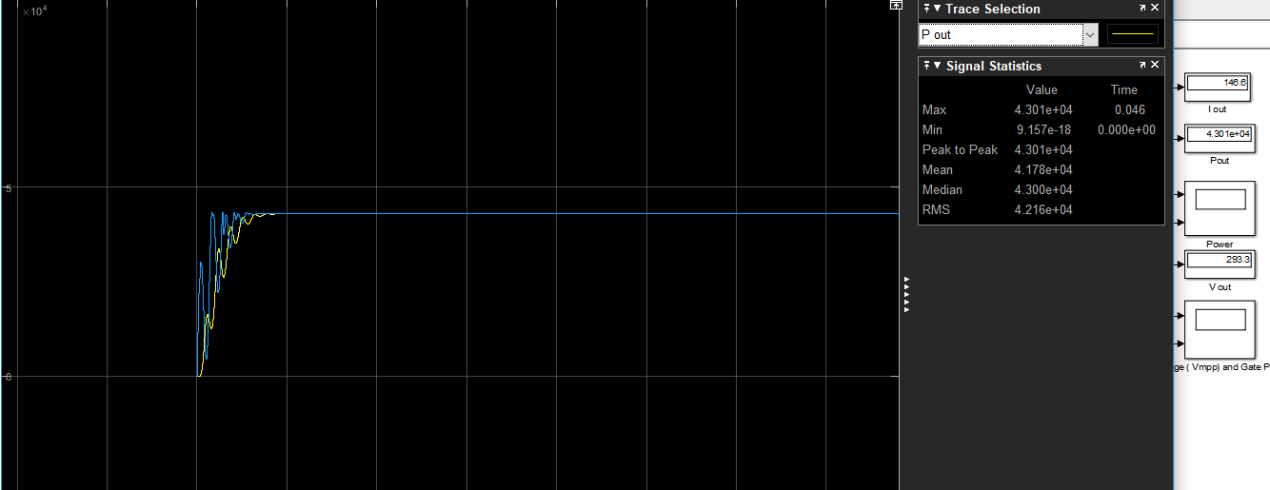

* At Irradiance 300 W/m2 – Pout ( in scope ) = 2.697e^4

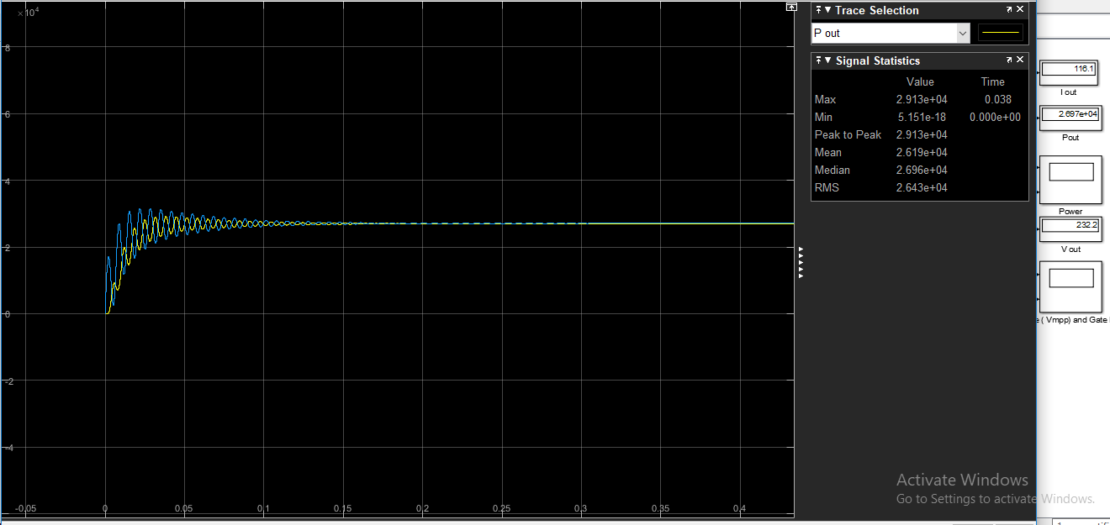

**VARIATION WITH TEMPERATURE AT A FIXED IRRADIANCE - 1000W/m^2**

|  |  |  |  |  |
| --- | --- | --- | --- | --- |
| Temperature  ( in degree ) | Power  ( max in W ) | Power  ( output from simulation in W ) | Voltage  (in Volts ) | Current  (in Amp.) |
| 25 | 1.06e^5 | 1.002e^5 | 454 | 225 |
| 32 | 1.032e^5 | 9.55e^4 | 437 | 219.1 |
| 38 | 1e^5 | 9.14e^4 | 426 | 213.7 |
| 40 | 9.9e^4 | 9.00e^4 | 424 | 212 |
| 45 | 9.6e^4 | 8.602e^4 | 412 | 207.4 |

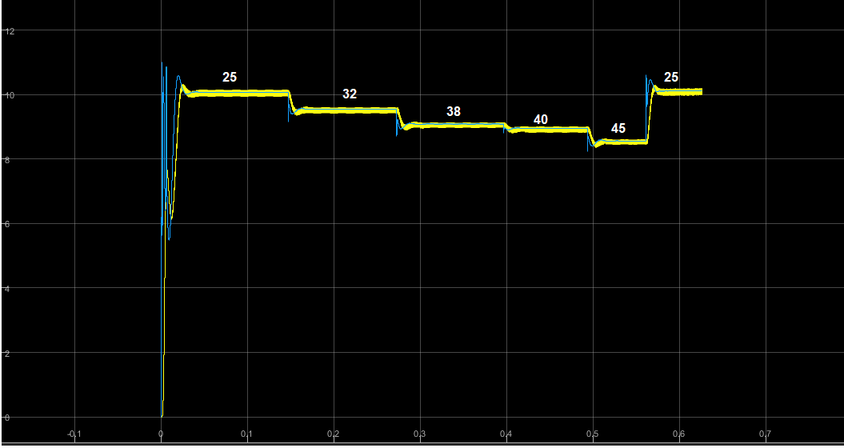

**Figure showing :**

**Power Vs Time , varying temperature [ 25, 32, 38, 40, 45 ] deg. At 1000W/m^2 irradiance.**

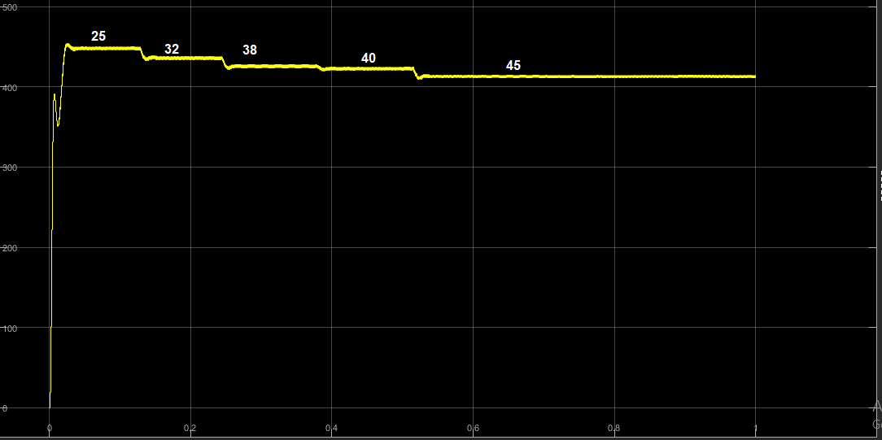

**Figure showing :**

**Voltage Vs Time , varying temperature [ 25, 32, 38, 40, 45 ] deg. At 1000W/m^2 irradiance.**

**CONCLUSIONS**

**When Irradiance vary and temperature is kept constant.**

* With decrease in irradiance value , output power & voltage decreases.
* There is a small variation in Vpv of changing irradiance value but in Ipv , the variation is large.

So, we can say change in irradiance will effects the short circuit current (Ipv).

**When Temperature vary and Irradiance is kept constant.**

* With decrease in Temperature value , output power & voltage increases.
* There is a not much variation in SC current of changing temperature value but in OC voltage , the variation is of considerable amount.

So, we can say change in temperature will effects the open circuit voltage.

* MPPT plays an important role to reach out the maximum power output ( comparison is provided above in table ) , if MPPT system is not there the output power is arbitrary and consumer will not get maximum benefit of the solar pv array ( in terms of power output.)
* MPPT P&O algorithms are of two types in terms of there implementation , here I am using Vref ( as a output of MPPT function block ) , then to generate duty cycle , compare it with the repeating sequence , also to reduce error and speed up the process of convergence PI controller is used ( the value of Kp , Ki are randomly chosen after watching the output in scope ). Another method is changing dutycycle directly using P&O algorithm but research says that , this way will not provide accurate results.

References –

-> IEEEXplore – MPPT Algorithm P&O for solar pv array using Fuzzy systems.

-> Power Electronics and drives by M.Rashid